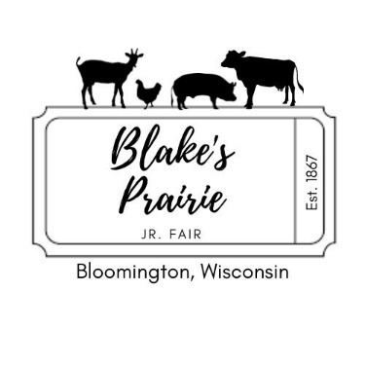

Dear Leaders,

Welcome to another exciting year of the Blake’s Prairie Jr. Fair. We will be sponsoring a king and queen contest to be held in conjunction with the 2024 Blake’s Prairie Fair (July 19-21). We encourage Clubs and Organizations to sponsor BOTH a king and a queen candidate, however you are not required to have both a king candidate and a queen candidate. The winners will be crowned in a royalty ceremony Friday evening and will reign over the remainder of the fair. The royalty will receive the appropriate royalty items and a cash award. All other candidates will receive a gift.

The winners will be decided by a tally of votes received before the fair. Each person who purchases a fair button before the fair will be entitled to one vote for a king and one vote for a queen. The buttons and ballots must be turned into us by **4** p.m. on Thursday, July 18th. If at any time you need more buttons or ballots, please contact Sara Hampton. Please designate a person responsible for your clubs buttons, ballots and money. All need to be turned in by Thursday late afternoon, unused buttons must be turned in at this time also. We will be verifying money turned in to the amount of buttons sold.

If your club wishes to sponsor a king candidate and/or a queen candidate for the contest, the candidates must conform to the following rules

1. Be an active member of your club or organization

* Candidates are strongly encouraged to exhibit projects at the current fair 2. Must reach his or her 15th birthday by July 1, 2042: but must have not

Reached the 19th birthday by the same date

3. Able to be at the fair during most festivities

4. Must not have been a candidate for this honor previously

If you club or organization wishes to sponsor a candidate or candidates, please return the attached form completed with the necessary information by May 20, 2024**,** so we can get buttons and ballots to your club by the end of May or early June. YOU DO NOT HAVE TO SPONSOR A CANDIDATE(S) IN ORDER TO SELL BUTTONS. Just contact Sara Hampton @ 412-4506 or Jessica Muller @ 412-0838.

Please see a complete list of events and fair book on our website:

www.blakesprairiefair.com. Extra king/queen forms are available on website also.

Sincerely,

Jessica Muller

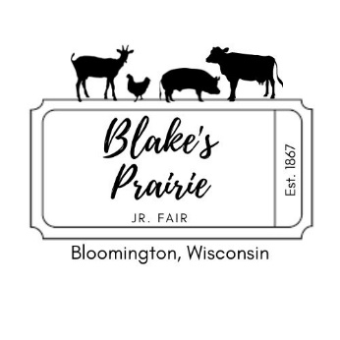

**CANDIDATE INFORMATION FORM**

Candidate’s Name

________________________________________________________________________________

Organization or Club sponsoring Candidate

Age

Parent’s Names

Address

Phone Number

Candidate Bio (such as: number of years in organization or club, any offices held, committee assignments, honors or recognitions received, projects that you have shown, etc.)

_____________________________________________________________________________________  
  
_____________________________________________________________________________________

_____________________________________________________________________________________

PLEASE SEND WITH FORM, ONE OR TWO PICTURES OF YOURSELF